**What Will I Learn in HMS Yearbook?**

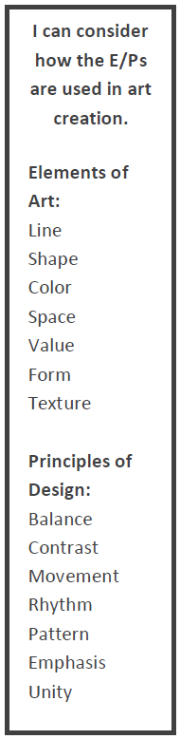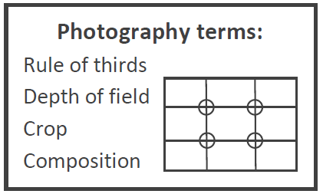

Vocabulary:

Ladder

Journalism

Theme

Copy

Design

Typography

Deadline

Marketing

Impact

Dominance

Layout

Headline

Caption

Edit

**Composition**

Rule of Thirds Balance



Leading Lines Foreground Object

Repetition repeating usage of fonts or elements to create consistency.

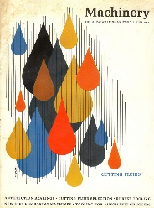 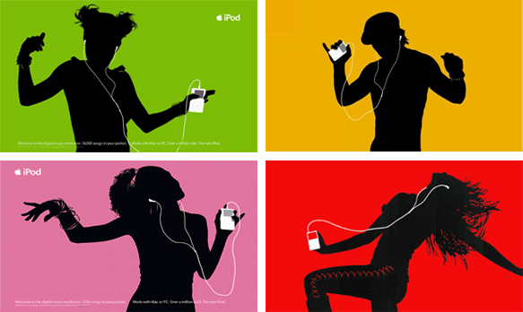



Symmetry and Framing

Patterns





Horizon

Alignment refers to the positioning of related objects or texts in design.

Left Aligned

Right Aligned

Center Aligned

Justified

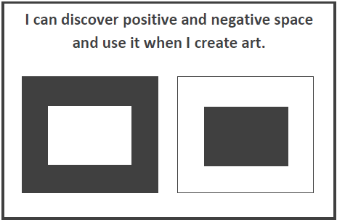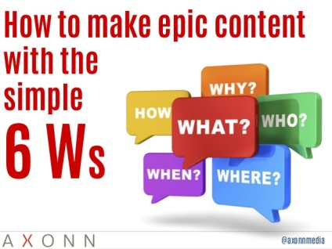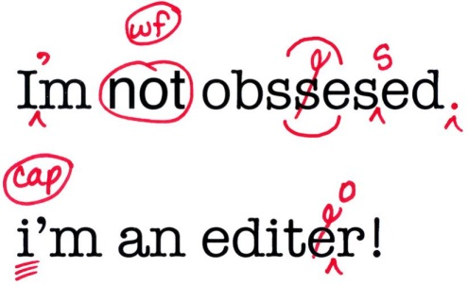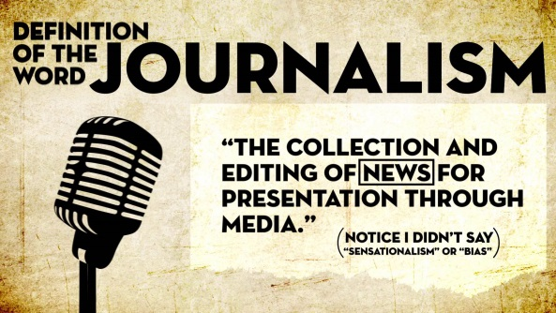Lines Reflection

Contrast helps elements stand out by comparing and creating differences.

Color Size

**BIG** small

Tone Type

 Type Type

**COLORS**

**Warm** = Red, Orange, Yellow

**Cool** = Green, Blue, Purple

**Monochromatic** = One hue plus tints, shades and tomes of that hue.

**Complementary** = Two opposite colors on the color wheel.

White Space is the space or gap between two elements.

 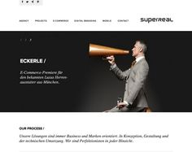

Proximity

The distance

of each

individual

design element.

Movement

Can be achieved by using graphic elements that direct the viewer’s eye.



